ØØ Explanation :
- We are given a series of numbers. The length of series is stored at memory location D000 H. We will initialise register C as counter with the length of the series.
- We will initialise the accumulator with 00 H, so that the sum can be stored in the accumulator.
- The series begins at D001 H. So, we will initialise HL the register pair as memory pointer to point the series.
- Using add instruction, add the contents, of the accumulator with the contents of memory location pointed by HL register pair. The result of this addition will be stored in the A register.
- Then we will increment HL to point to next memory location of the series. Decrement the count in register C. Continue this process till the count is zero i.e. all the numbers in the series are added.
- Store the result at memory location E000 H.
Example : Let D000 = 05 H i.e. series is of 5 numbers.
D001 = 08 H
D002 = 12 H
D003 = 74 H
D004 = 34 H
D005 = 04 H
Result = 08 H + 12 H + 74 H + 34 H + 04 H = C6 H
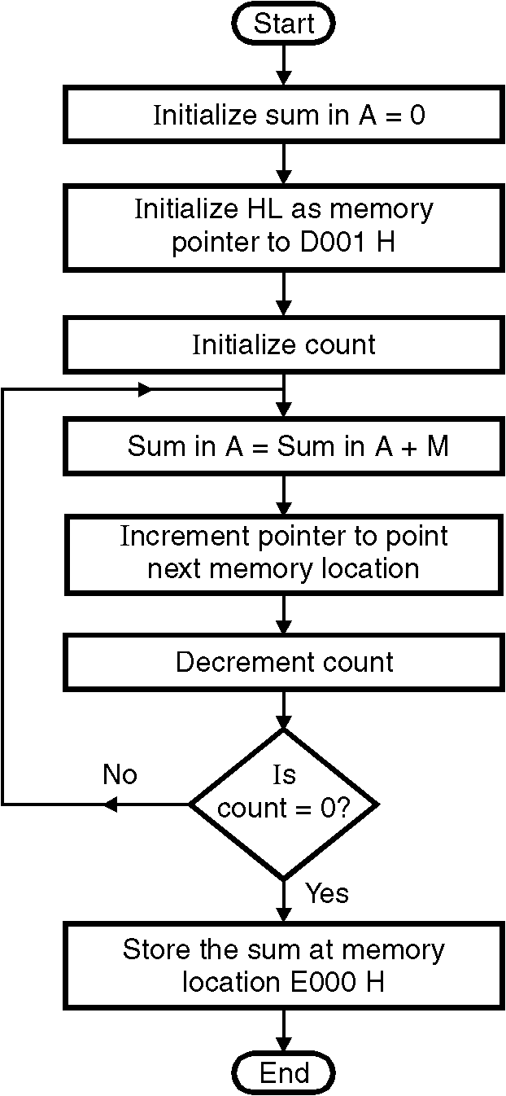
E000 H = C6 H.
ØØ Algorithm :
Step I : Initialize the register C with count.
Step II : Initialize sum in accumulator = 0.
Step III : Initialize the pointer to memory location
D001 H i.e. first number of series.
Step IV : Add the numbers in series.
Step V : Increment memory pointer to
next memory location.
Step VI : Decrement count
Step VII : Check if count = 0, if not goto step IV
Step VIII : Store the result at memory location E000 H.
Step IX : Stop.
ØØ Flowchart : Refer flowchart 15.
ØØ Program :
Instruction Comment
LDA D000 ; A = contents of location D000 H
MOV C, A ; Initialize counter
XRA A ; sum = 0
LXI H, D001H ; Initialize HL as memory pointer
; for the series
L1: ADD M ; SUM in A= SUM in A + M
INX H ; Increment pointer
DCR C ; Decrement counter
JNZ L1 ; if counter 0 repeat
STA E000H ; store the result at memory location E000 H
HLT ; Terminate program execution Flowchart 15

